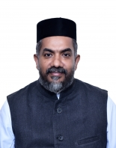 | Rev. Fr. Aju Abraham  Vicar & President  +971542525833  vicar@stocdubai.com |  | 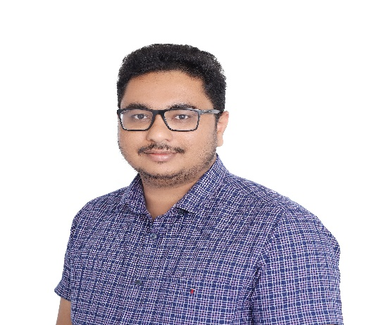 |  | Robin Babu  Secretary [R-290]  +971554616862  ocymdubai@gmail.com
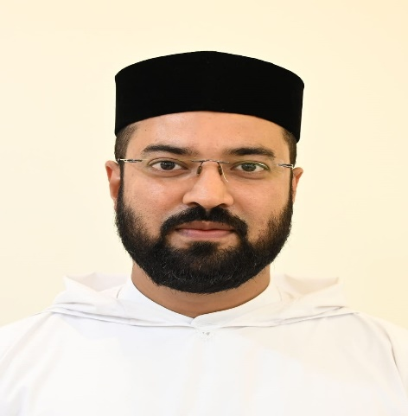 | Rev. Fr. Jackson Mathews John  Assistant Vicar  +971559394059  assistantvicar@stocdubai.com |  | 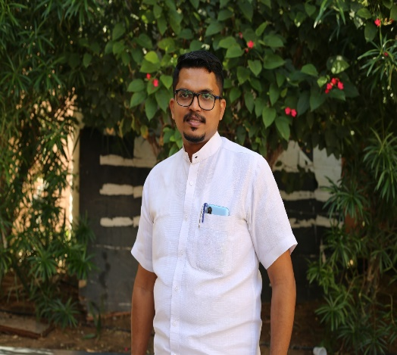 |  | Jittin Joseph Abraham  Joint Secretary [J-683]  +971551281176
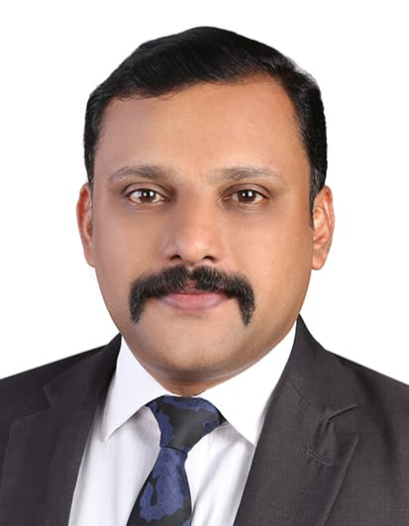 | Cherian Oommen  Vice President [C-103]  +971504255951 |  | 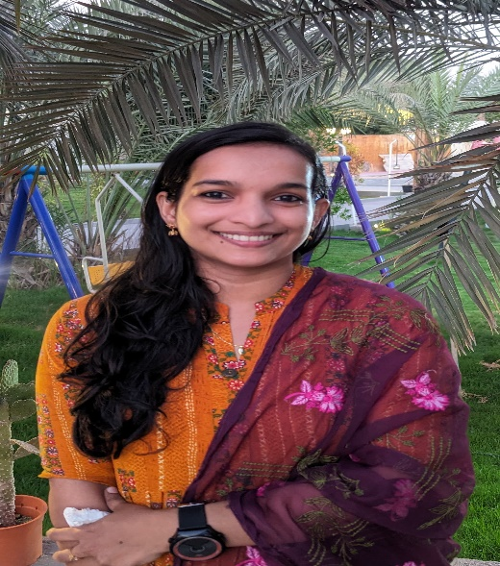 |  | Julie Mary Mathew  Joint Secretary [J-823]
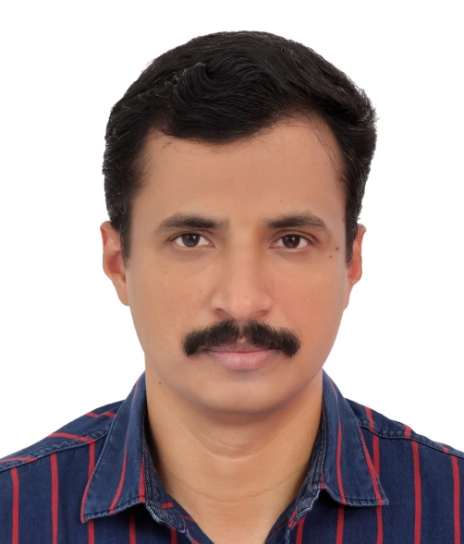 | Suresh Pappachen  Treasurer [S-387]  +971507597067 |  |  | 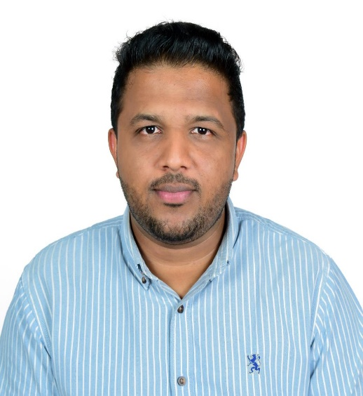 | Santo Zachariah  Ex Officio [S-627]

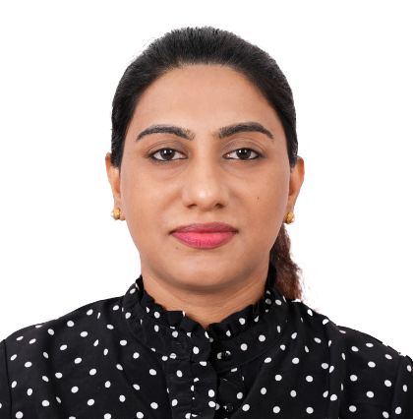 |  | Renju Vivek  Committee Member [V-267] |  | 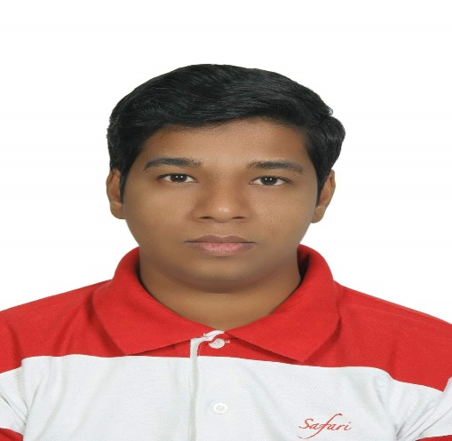 |  | Samuel George  Committee Member [S-456]
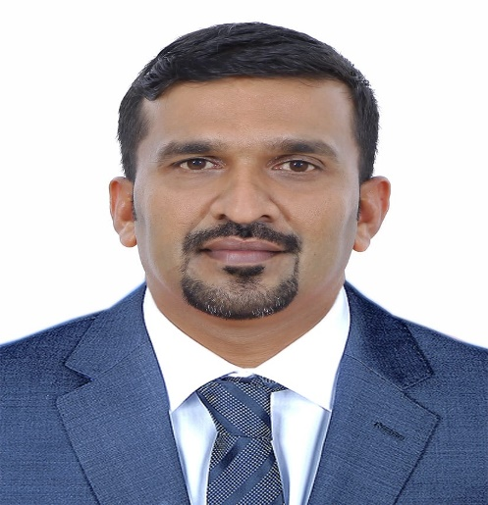 |  | Ginesh Varghese  Committee Member [G-240] |  | 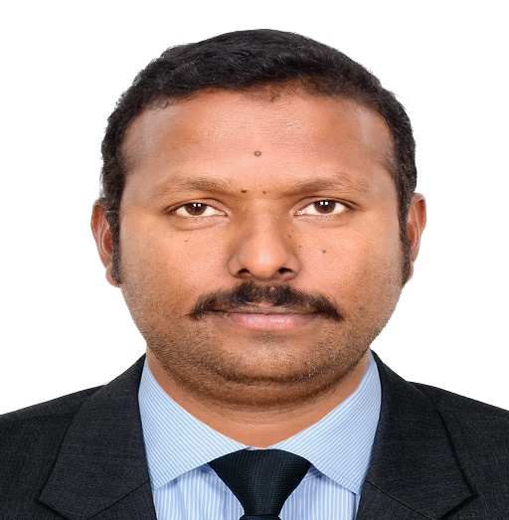 |  | Siju K Mathew  Committee Member [S-702]
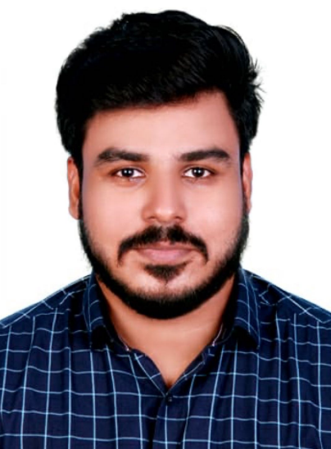 |  | Jithin John K  Committee Member [J-849] |  | 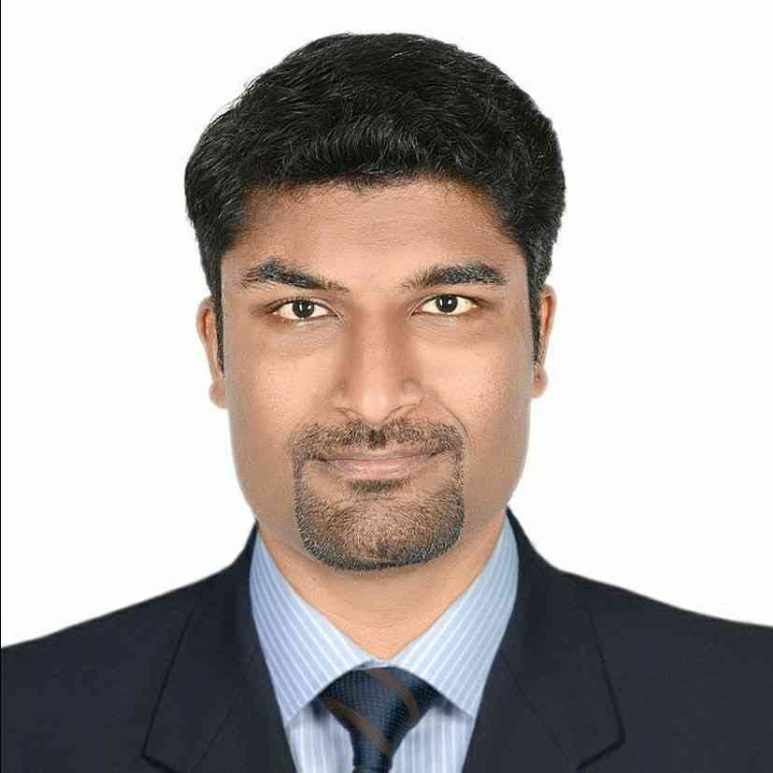 |  | Sonu Roy Mathew  Committee Member [S-780]
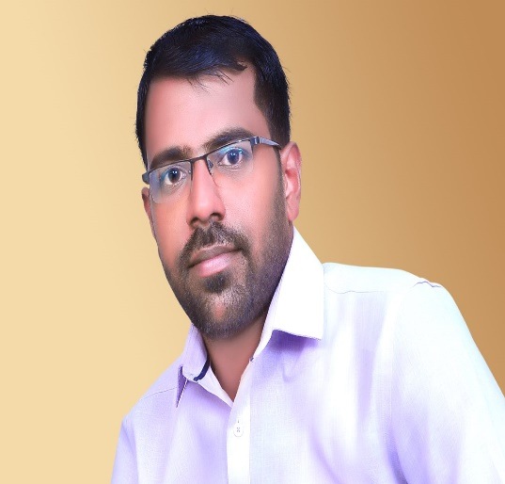 | Sajith Mathai  Committee Member &  Divyabodhanam Coordinator [S-771] |  |  |  | 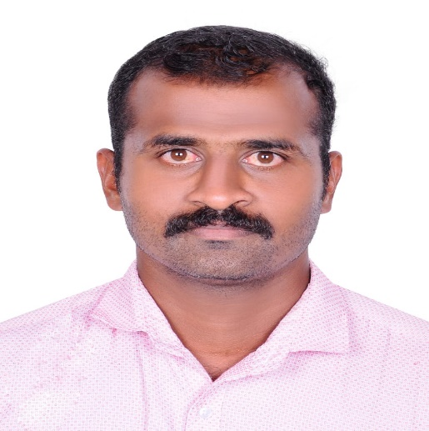 |  | Aju Varghese  Inventory Controller [A-401]
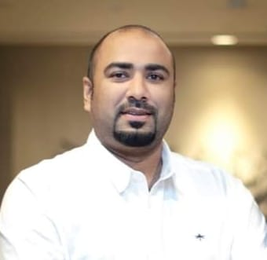 | Manoj Mathew  Dhwani Coordinator [M-372] |  |  |  | 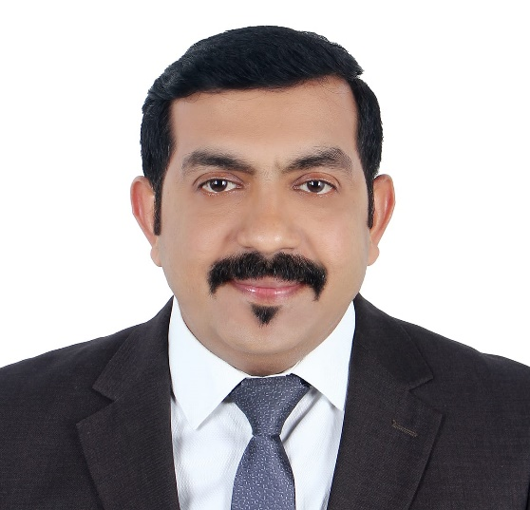 |  | Rinu Thomas  Internal Auditor [R-150]
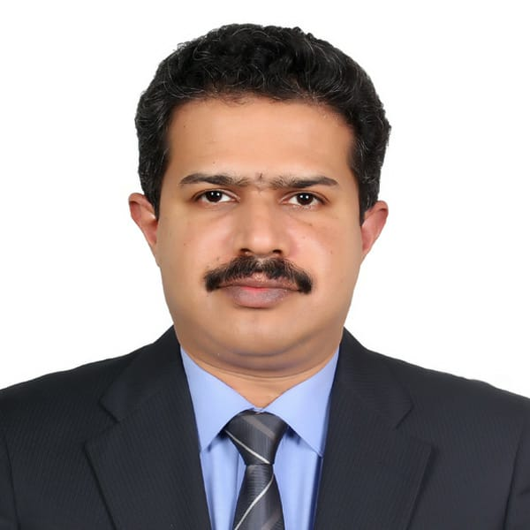 | Ginu George  Edifycare Convenor [G-244]
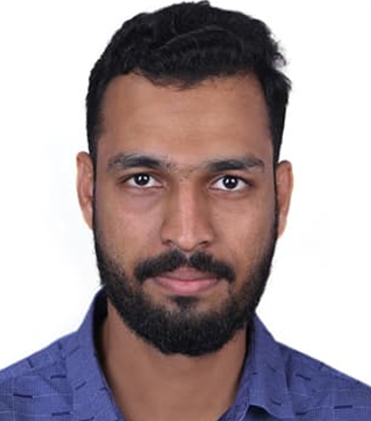 |  | Ginil C George  Librarian [G-324]
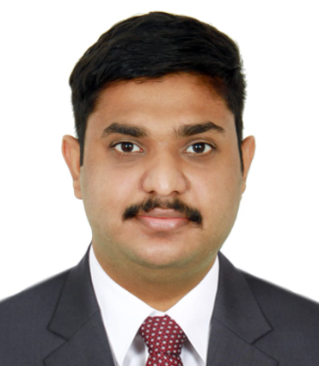 |  | Shabin Shajan Mathew  Assistant Librarian [S-843]

